Assignment-1

**Coding Assignments**

1. **Hello World Program**: Write a Java program that prints "Hello World!!" to the console.

class First_hello{

public static void main(String args[]){

System.out.println("Hello World !!");

}

}

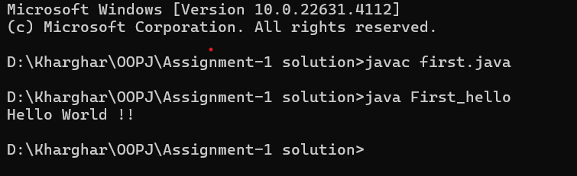

**2.Compile with Verbose Option**: Compile your Java file using the -verbose option with javac. Check the output

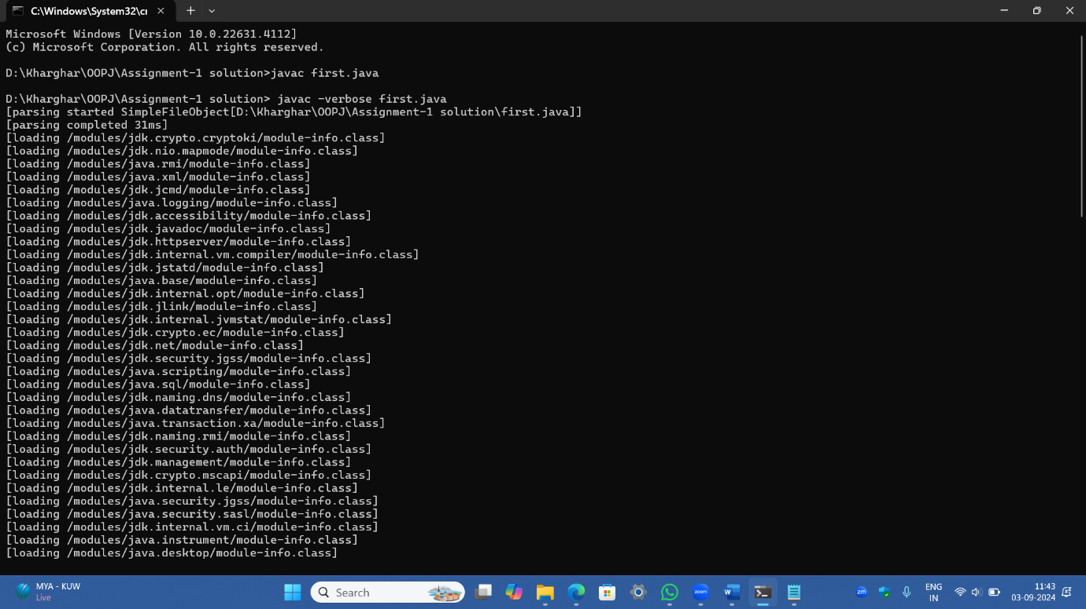

3. **Inspect Bytecode**: Use the javap tool to examine the bytecode of the compiled .class file. Observe the output.

